**Business Requirement Document (BRD)**

**Project Name** : Customer Complaint Management &

Resolution System

**Version**: 1  
**Date** : 20-06-2025

**Author** : Abdul Sohail

# **Revision / Document History**

|  |  |  |  |
| --- | --- | --- | --- |
| **Date** | **Version** | **Description** | **Author** |
| 24-06-2025 | 1 | Author | Abdul Sohail |
| 25- | 1.2 | Author | Abdul Sohail |
|  |  |  |  |

# **Table Of Content**

|  |  |
| --- | --- |
| **Title**  **Page no** | |
| Business Requirements   * Problem Statement * Business Goal * Key Objectives * Success Matrics * Business rules | 4 |
| Scope and Limitations   * Scope (In/Out) * Stakeholders * Business Constraints * Assumptions * Dependencies | 5 |
| Business Process   * AS-IS (Current state) * TO-BE (Future state) | 6  7 |
| Stakeholder Requirement   * Functional requirements * Non – Functional requirements | 8 |
| Glossary Of Terms | 9 |
| Appendix   * Business Case * Use Case Map * Process Map | 10 |
| Approval & Sign-Off | 11 |

# **1. Business Requirements**

* 1. **Problem statement (Need)**

The company receives customer complaints through multiple channels (emails, phone, app) but lacks a centralized system to handle, assign, and track complaint. This lead to delays, missed follow-ups, and customer dissatisfaction or retain.

* 1. **Business Goals**
* Reduced complaints
* Increase customer satisfaction
* Customer retention
* Enable performance monitoring
  1. **Key Objective**

To built a centralized digital platform that:

* Capture complaints from various sources
* Assign them to right technical team
* Allow tracking and resolution to complaints
* Generate reports and dashboard for performance analysis
  1. **Success Matrics**
* 90% complaints resolved within (48 hours)
* The system will be develop as a prototype and not connected to live databases
  1. **Business rules**
* Complaints cannot be resolved without customer feedback or agent comments
* Agents can only view complaints assign to them

**2. Scope and Limitations**

**2.1 Scope**

2.1.1 In-scope

* Complaint login via form
* Auto-assignment and tracking
* Status update & notification
* Reporting dashboards

2.1.2 Out-of-scope

* Chatbot integration
* External CRM sync

**2.2 Stakeholders**

|  |  |  |
| --- | --- | --- |
| **Stakeholder Type** | **Stakeholder** | **Role** |
| External | Customer | Submit complaints |
| Internal | Support agent | Resolve complaints |
| Internal | IT team | Build the support system |
| Internal | Support manager | Track and monitor |
| Internal | Product manager | Analyze complaints trends for improvements |

**2.3 Business Constraints**

* Limited budget and time for development (build within 4 weeks)
* 25% reduction in complaints duplication
* Improved customer satisfaction

**2.4 Assumptions**

* Customer should have internet
* Support team are trained to use the new system
* Notification system (email and SMS)

**2.5 Dependencies**

DEP-1 : Timely availability of support team leads and managers is required to define complaint type

DEP-2 : The project highly depend on developer and technical team

DEP-3 : Training session must be provided to support agent and admin user for how to use complaint system effectively

**3. Business Process Overview**

**3.1 AS-IS (current state)**

* Customer calls or emails the support team to raise a complaints
* Complaints are logged in Excel sheets or notebooks manually
* Assigning complain depend on verbal communication
* No real time tracking process or manager have to real time visibility into complain status

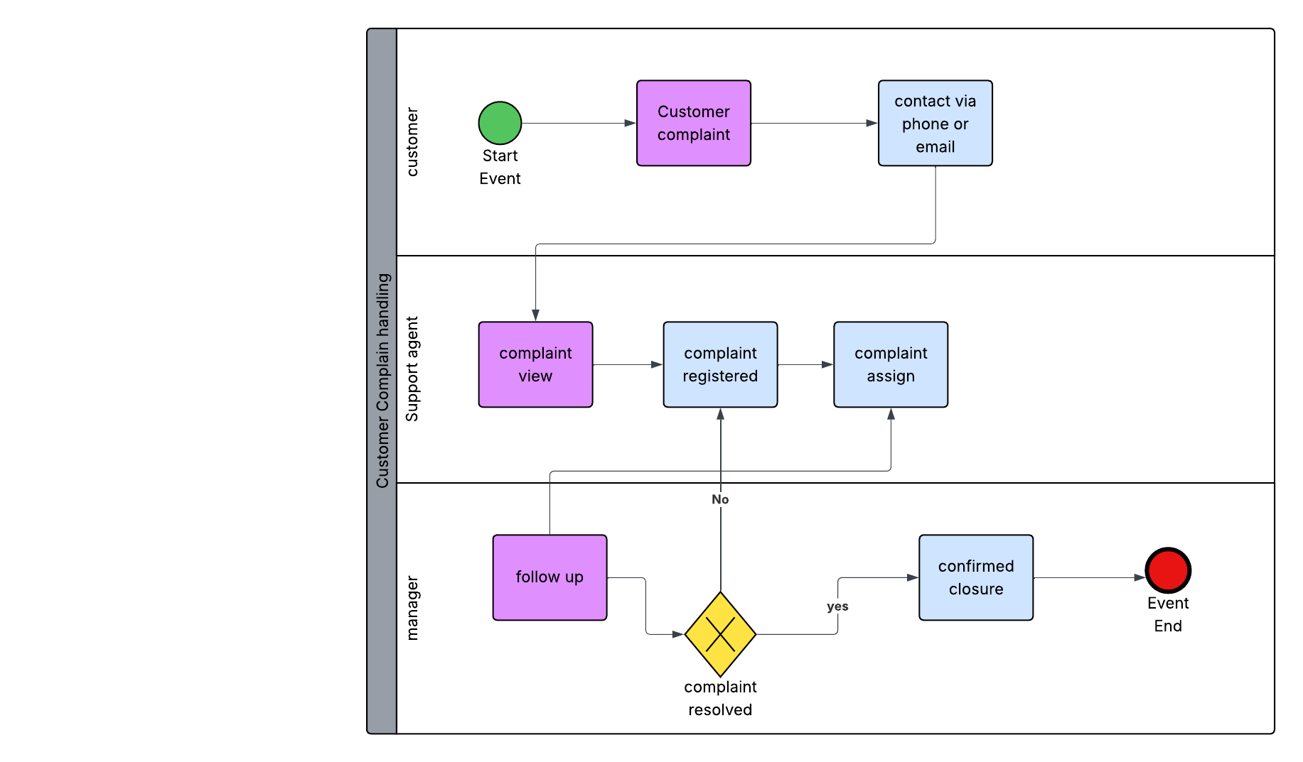

**3.2 TO-BE (Future State)**

* Customer raises complain via an online form or portal
* Each complaint get a unique **Ticket ID** and auto assigned to support agent
* Real time process tracking by the system, escalation happen automatically
* Agent update status in real time customer receive notifications
* Manager get a live dashboard with complaint metrics

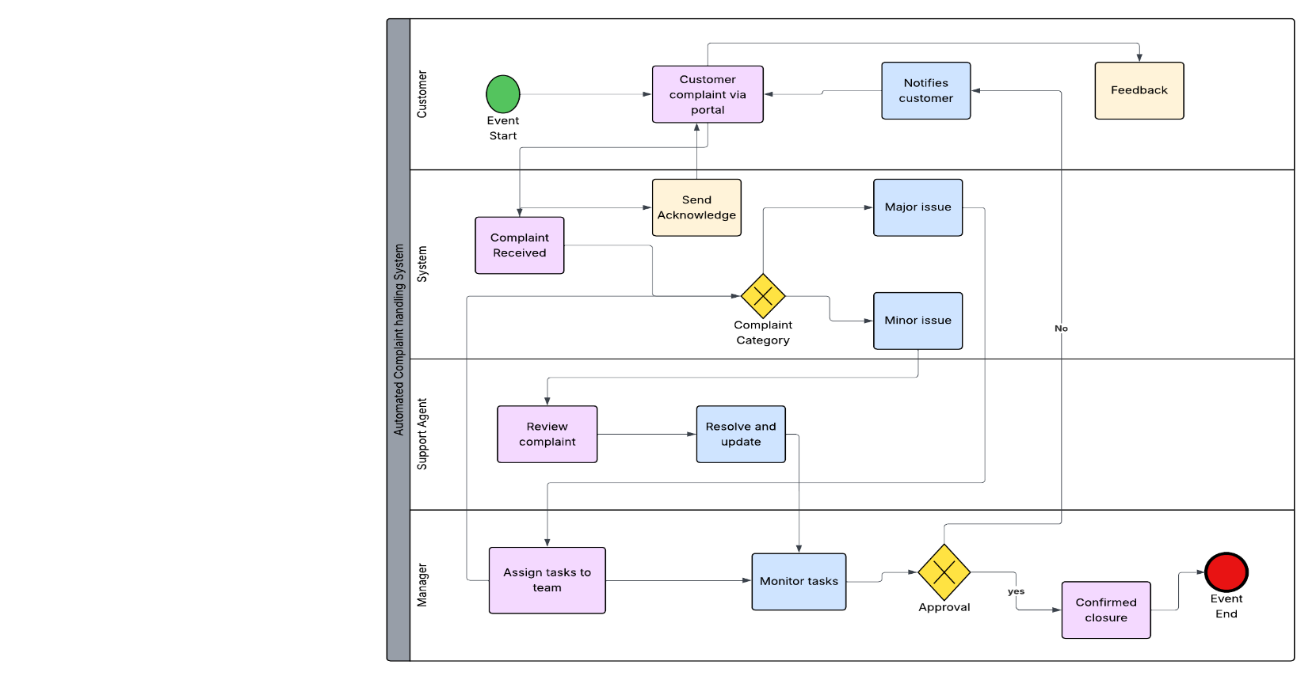

**4. Stakeholder Requirements**

**4.1 Functional Requirements**

|  |  |  |
| --- | --- | --- |
| **ID** | **Title** | **Description** |
| FR-1 | Complaint submission | The system shall allow customer to submit complaints via online forms with mandatory fields like Name, category, description |
| FR-2 | Unique ticket ID | Upon submission the system should generate a unique **Ticket ID** for every complaint |
| FR-3 | Complaint assignment | The system shall automatically assign the complaint to an available support agent based on category |
| FR-4 | Complaint status | Agents can update the complaints status (e.g., new, in progress, closed) |
| FR-5 | Reporting dashboard | Manager shall have access to a dashboard for agent performance analysis |
| FR-6 | Feedback collection | After resolution the system shall send a feedback form to the customer to rate service |

**4.2 Non-Functional Requirements**

|  |  |  |
| --- | --- | --- |
| **ID** | **Title** | **Description** |
| NFR-1 | Performance | The system should be able to handle up to 10,000 users simultaneously without degradation |
| NFR-2 | Availability | The system shall be available 99.9% of the time, excluding maintenance |
| NFR-3 | Security | All complaints data must be encrypted and access should be role based (customer, agent, manager, admin) |
| NFR-4 | Scalability | The system should allow for future expansion such as chatbot |
| NFR-5 | Usability | The interface shall be user-friendly and accessible to user with minimal technical knowledge |

**5. Glossary Of Terms**

|  |  |
| --- | --- |
| **Term** | **Definition** |
| complaint | A reported issue or dissatisfaction submitted by customer |
| Customer support agent | A team member responsible for receiving and resolving customer complaints |
| Dashboard | A visual interface showing customer complaints and agent performance |
| Feedback | Comments or rating provided by the customer after resolution to assess service quality |

**6. Appendix**

**6.1 Use Case**

* Use case document

**6.2 Current State Process Map**

* AS-IS map

**6.3 Future State Process Map**

* TO-BE map

**6. Approvals and Sign-Off**

|  |  |  |  |  |  |
| --- | --- | --- | --- | --- | --- |
| **Name** | **Role** | **Reviewer** | **Approver** | **Signature** | **Date** |
| Abdul sohail | BA | yes | yes | N/A | 25-06-2025 |
| Rakesh | Project manager | yes | yes | N/A | 25-06-2025 |
| Naina | Product owner | yes | yes | N/A | 26-06-2025 |
| Suresh | Technical lead | No | No | N/A | 26-06-2025 |